SHRI VILE PARLE KELAVANI MANDAL’S

**SHRI BHAGUBHAI MAFATLAL POLYTECHNIC**



PROGRAM: **INFORMATION TECHNOLOGY**

COURSE NAME: **MULTIMEDIA AND ANIMATION**

COURSE CODE: **MSA190903**

SEMESTER: **III**

MINI PROJECT TITLE:  **ANIMATION OF 3D CUBES & CUBOID**

PROJECT GUIDE: **Mrs. SWAPNA NAIK**

STUDENT NAME:**SAHIL SINGH(T050) & VARUN JAIN(T052)**

STUDENT ROLL NO: **57498210050 & 57498210052**

**MULTIMEDIA AND ANIMATION**

Animation is the art of presenting still photographs with the help of various computer-based techniques in a manner which gives an impression to the viewer that it is running like a film. It could be a mixed version of multimedia text, graphic art, sound, animation, and video sourced through computer or some other electronic media.

**SOFTWARES**

* **BLENDER**

Blender is the **free and open source 3D creation suite**. It supports the entirety of the 3D pipeline—modeling, rigging, animation, simulation, rendering, compositing and motion tracking, even video editing and game creation.

* **MP4 & MEDIA PLAYER**

After Completing the Animation In Blender, we have to render and save the file in the **MP4**mode and then after downloading we can view it in the **Media Player** provided by Windows to see the MP4 in proper Video Format

**PROJECT TITLE**

* **ANIMATION OF 3D CUBES & CUBOID**

**FEATURES**

* Camera
* Cube
* Cuboid
* Plane
* Light

**TOOLS**

* Layout Mode
* Edit Mode
* Object Mode
* Scene
* Camera Tool
* Rendering Tool
* Scaling Tool(short cut keys)

**PROCEDURE**

* Creating Objects
* Creating Cube,Cuboid,Plane
* Moving from x-y axis
* Adding Textures
* Saving Scale
* Rendering Animation

**STEP1:** Browse some reference videos, images, templets according to requirement.

**STEP2:** Press Shift+A to add Objects whichever you want according to your design/animation.

**STEP3:** Create a Animation to move your objects.

**STEP4:** Apply keyframe for each object you move to run them.

**STEP5:** Add Camera from the right menu bar.

**STEP6:** Adjust your camera by pressing Numpadp’s Zero(0).

**STEP7:** Add the Color & texture.

**STEP8:** Once done click “Render” from the above Menu Bar.

**STEP9:** After Clicking Render Click on “Render File”.

**STEP10:** Save The File with any extension you want.

**PROJECT RESULT**

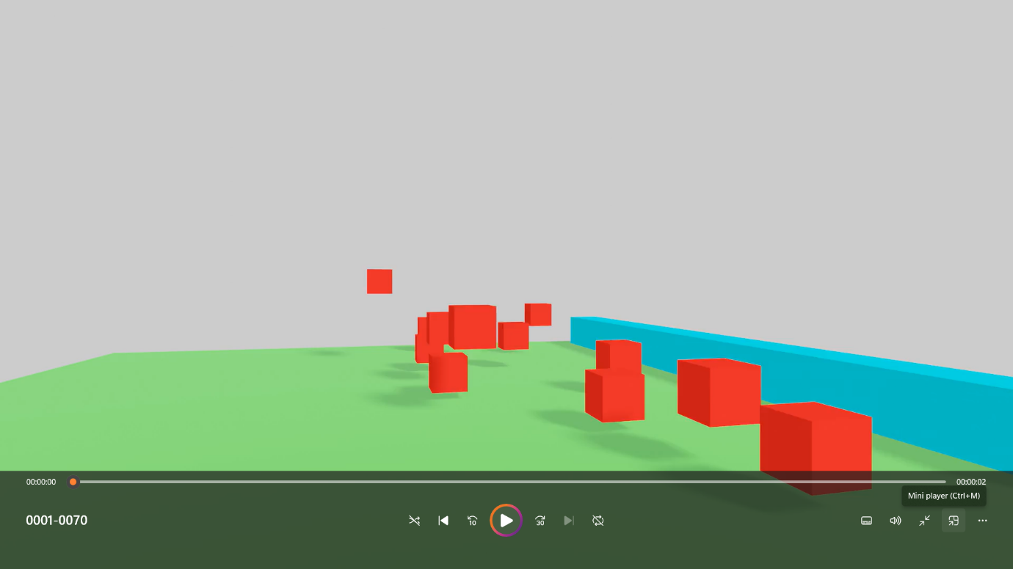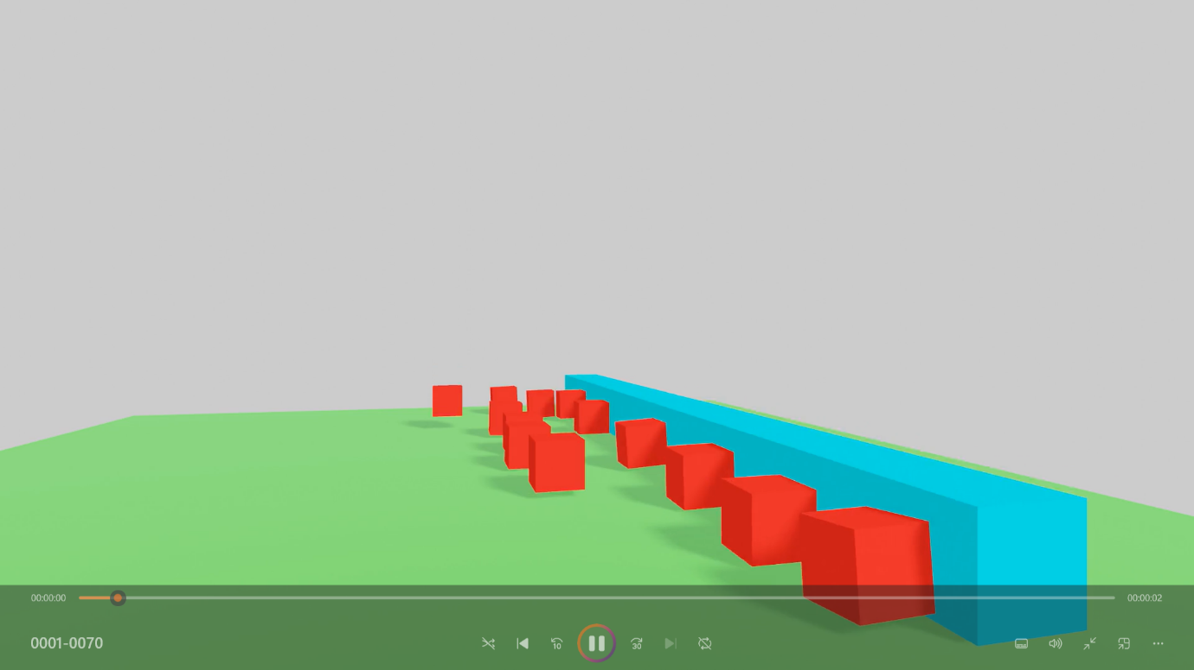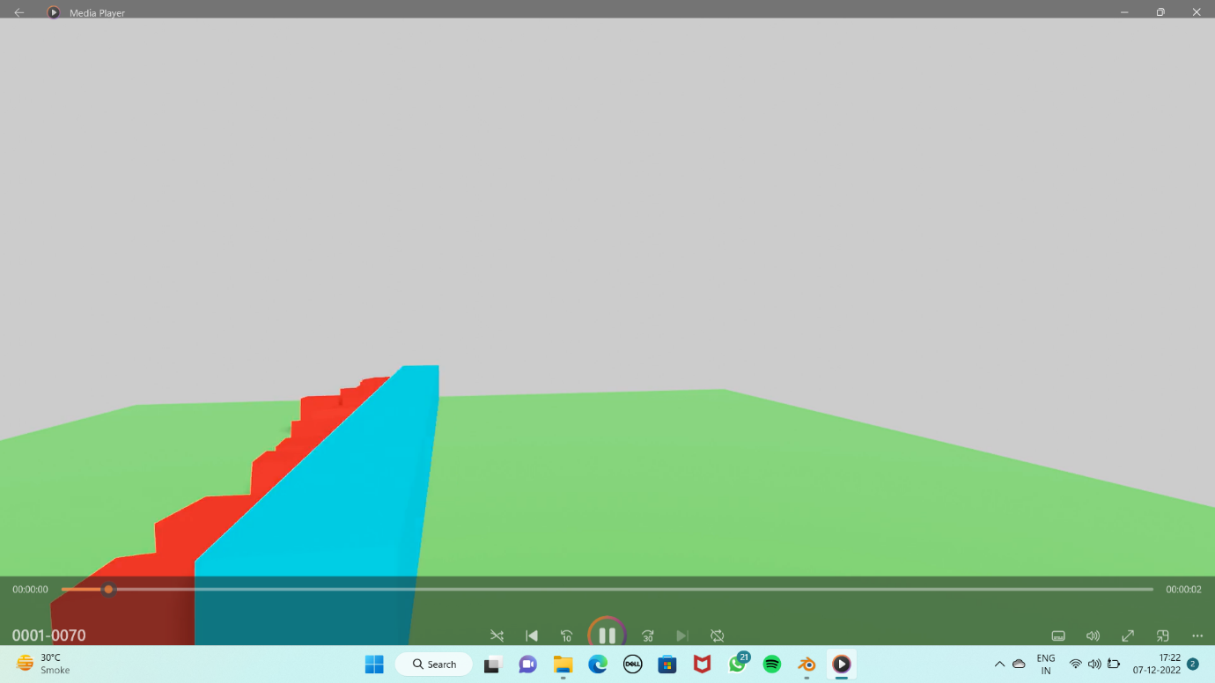

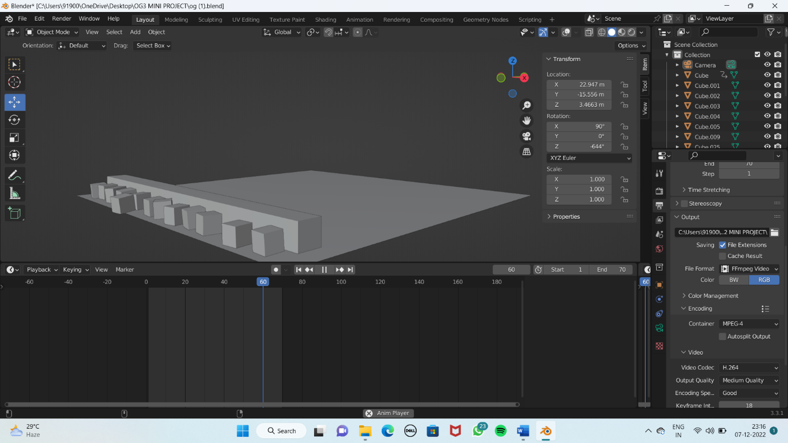

**CONCLUSION**

Animation has made a huge impact on entertainment, movie industries, and kids. Computer Animation made entertainment more interesting and enjoyable. Through this course I have proposed, implemented, and demonstrated an animation framework that enables the creation of realistic animations. Finally, although the technology today is advanced, there’s a greater future in store for Computer Animation.